C:\Program Files (x86)\Microsoft Office\MEDIA\CAGCAT10\j0298897.wmf

**ON THE ROAD to Film & Communication Camp Curriculum**



Tentative dates: Atlanta - June 8, 2020- July 10, 2020

Tentative dates - Charlotte- July 27, 2020- August 23,2019 (condensed version)

Registration Fee: $55- non-refundable

**Camp Hours-** 9:00 A.M- 5:30 PM Monday-Friday

Fee: Field Trips are extra

**Camp closes promptly at 5:30 (**All young people must be picked up or leave facility by 5;45 p.m. or fee will be assessed)

*Youth Ages 12-18 years old can participate in classroom activities

**Young people 19-25 years old may participate as Interns, Class Monitors and Mentors. However, they may attend Editing classes as students. (Fee to attend - $40.00 per student).

Minimum 20 students to start a class.

Welcome To On The Road to Summer Camp!

The 2019-2020 Camp is interactive so young people can receive best and beneficial results when it comes to navigating *Arts In Action.*

***In 2017, we implemented “Summer Film Training Experience” to offer young people 12-25 years old opportunity to participate in the making of Now That You Know movie. The young people were so engaged and focused on filmmaking and techniques surrounding the industry. Twenty young people were invited to participate in the project. However, more than 50 young people showed up weekly to learn. It was inspiring to see their commitment, talent and enthusiasm. Now That You Know movie is part of an HIV Initiative to education and bring awareness to the growing HIV infection rates among young people in inner city communities. The “Summer Film Training Experience” was truly an experience for the young people who walked away with knowledge, filmmaking skills and amazing self confidence. They spent hours on set, shadowing professionals and creating their film projects from a 2 weekend Editing class.

The 2019-2020 “On the Road to Summer & Communication Camp” is interactive and young people have opportunity to explore *Arts In Action* by learning and displaying their skills in filmmaking, music and technology.

**Schedule**

4 week Camp in Atlanta, Georgia and condensed 3 week version to be implemented in Charlotte, North Carolina. Please see dates

**Week One**

**Day #1-** Registration, Lunch, Schedules

**Day # 2**- 09:00-12:00 Curriculum review and expectations

12:00-1:30 Lunch

1:30-2:30 Introduction to Communication

2:30-4:30 Workshop: “What did I say or What did you think I said”

4:30-5:30 Q & A

**Day # 3** Film 101

09-00-5:30 History of Film

**Day # 4** Developing film projects

09:00-12:00 The Script

**https://www.celtx.com/index.html,

**https://www.writersstore.com/how-to-write-a-screenplay-a-guide-to-scriptwriting/

12:00-1:30 Lunch

1:30-3:30 What is it that you want to say? – Begin script draft

3:30-5:30 Treatments

What is a treatment? Explain

**Day # 5** **Discussion-** What you learned the first week

**Week Two**

*Day # 1* 09:00-12:00 Review- The Script

12:00-1:30 Lunch

1:30-3:30 Breaking down the script

3:30-5:30 Researching script format, formatting your script

**Day # 2** 09:00-12:00 Script-Presentation

12:00-1:30 Lunch

1:30-5:30

**Day #3** Telling the story

09:00-12:00 Organizing your Story

12:00-1:30 Lunch

1:30-5:30 Interactive Presentations/ Elements such as Music, Song, Monolog, Play

Day # 4 Continuation of Presentations

Day # 5 Review

**Week Three**

**Day # 1** Acting Classes

**Day # 2** Directing Classes

**Day # 3** Camera Operation Classes (Director of Photography)

**Day # 4and # 5** Technology- Creating “Do it yourself” film, play, music projects

,

**Week #4** Using Technology to tell the story

**Day # 1** Editing Workshop

**Day # 2** Editing film and music projects

**Day # 3** Finish editing project & Video Samples

**Day # 3** **Screening- Public Presentation**

**Day # 4** Field Trip- Film Festival

**Day # 5** Lunch with Sponsors, Awards, Review and End of Camp

** Please note that curriculum may change to accommodate learning progression.

***This is an America RAVES sponsored project. Activities are part of the “Arts In Action” Communications Program.

All rights reserved © 2018.

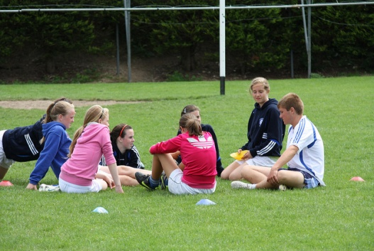

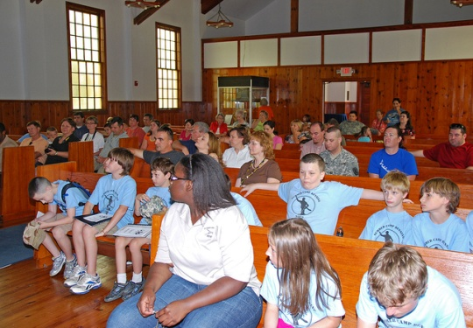

**Budget**-(based on 20 young people x 4 weeks)

**Revenue**

Class Sessions ($85 per week x 4 weeks) (Atlanta 6,800.00

Class Sessions ($85 per week x 3 weeks) (Charlotte) 5,100.00

Walmart 500.00

Donations 480.00

Registration 1,100.00

Total 13,980.00

**Expenses**

Facility ($300 per week x 7) 2,100.00

Instructors ($350 per week x 2) (Atlanta) 2,800.00

Interns ($9 per hour x 5 hrs day) 1,080.00

Instructors ($350 per week x 2) (charlotte) 2,100.00

Interns ($9 per hour x 5 hours day) 1,080.00

Safety Training 150.00

Activities Fees (Film Festival, Art Show, Photo session) 940.00

Award Ceremony and Reception (50 people) 700.00

Marketing 660.00

Lunch donated

Snacks donated

Field Trip (Bus/2 Vans) 900.00

Equipment 2,001.00

Insurance 57.66

Total $14,568.00